SALES ANALYSIS DASHBOARD
Project overview
This Global Sales Performance dashboard is a UX-driven Power BI app that lets commercial leaders move seamlessly between high-level KPIs and detailed rankings of regions, resellers, and salespeople.​
The design combines custom navigation, bookmark-driven views, field parameters, and a pop-out filter panel to deliver a modern web-app experience rather than a static report.​​
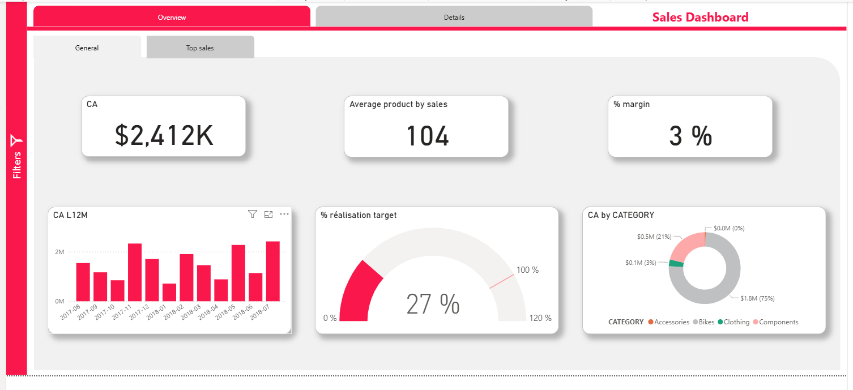
Overview and details navigation
The report uses Overview and Details tabs implemented with buttons and bookmarks, so users can switch context instantly without changing physical pages, improving both performance and usability.​
On the Overview tab, executives see KPIs for revenue (CA), average products per sale, and % margin, together with visuals such as CA L12M, a target-achievement gauge, and revenue by category, giving a concise snapshot of recent performance.​​
Advanced filter and field-parameter experience
A dedicated Filters button opens a slide-out filter panel containing slicers for Year-Month, Salesperson, Country, Category, and Region, keeping the main canvas clean while still enabling deep slicing when needed.​​
Key visuals use field parameters so users can dynamically switch what metric is displayed (for example, toggling between CA, target achievement, or % margin in the KPI L12M section) without duplicating visuals, demonstrating modern, metadata-driven Power BI modelling techniques.​
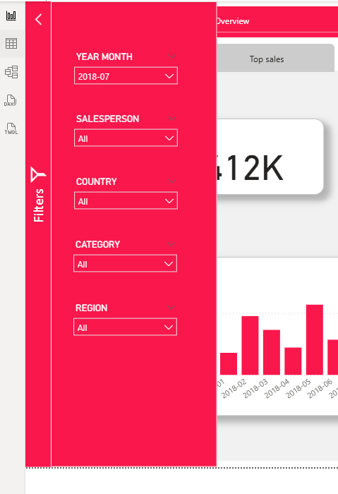
Top sales analysis with bookmarks
The Top sales sub-tab uses bookmarks to toggle between visual states on the same page: selecting “Top sales” reveals two focussed visuals for Top 5 Resellers and Top 5 Sellers by revenue.​​
These visuals rely on Top-N DAX measures that respond to both slicers and field-parameter selections, ensuring that rankings always reflect the currently chosen period, region, and metric.​​
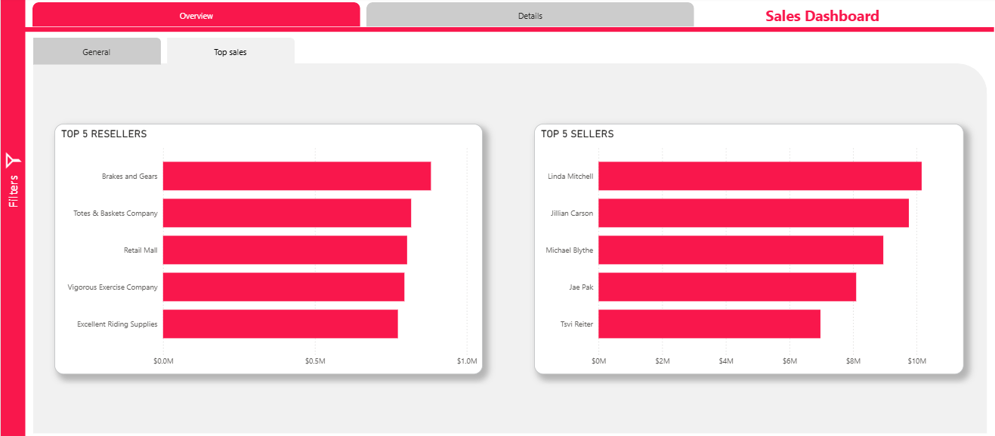
KPI L12M, ranking, and Excel-like detail
The KPI L12M area links directly to a CA & ranking by region table that lists each salesperson, their sales, and their rank both within region and globally, helping leadership quickly identify high performers by territory.​
An Excel-like matrix on the right shows revenue by year and month, cumulative revenue, and % of total, giving finance and sales-ops users a familiar grid view that stays in sync with all filters and field-parameter choices for a smooth end-to-end analytical workflow.
